**Docker Compose1**

* Docker Compose is a tool for defining and running multi-container applications. It is the key to unlocking a streamlined and efficient development and deployment experience.
* Compose simplifies the control of your entire application stack, making it easy to manage services, networks, and volumes in a single, comprehensible YAML configuration file. Then, with a single command, you create and start all the services from your configuration file.

Handson 1: Github repo(App code, docker file, docker compose yaml)

* <https://github.com/jakewright/tutorials/tree/master/docker>

Handson 2: Two-tier Python, Flask and MySql web application deployment using Docker compose

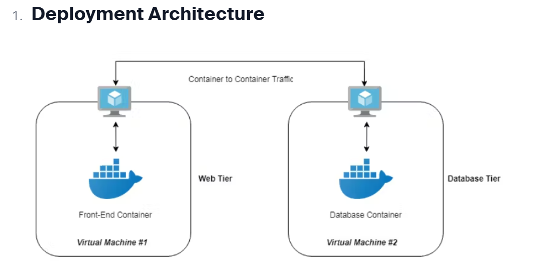

version: '3.9'

services:

mysql: # Container 1 of database

container_name: mysql

image: 'mysql:5.7' # Base image

ports:

- '3306:3306'

environment:

MYSQL_ROOT_PASSWORD: root

MYSQL_DATABASE: devops

MYSQL_USER: admin

MYSQL_PASSWORD: admin

volumes:

- 'mysql-data:/var/lib/mysql' # Binding of persistent volume

networks:

- twotier # user-defined bridge network

healthcheck:

test: ["CMD", "mysqladmin", "ping", "-h", "localhost"]

interval: 10s

retries: 5

start_period: 30s

timeout: 5s

flask-app: # Container 2 of frontend

build:

context: . # Building image using Dockerfile

ports:

- '5001:5000'

environment:

MYSQL_HOST: mysql # mysql is an database container name

MYSQL_USER: admin

MYSQL_PASSWORD: admin

MYSQL_DB: devops

depends_on: # Run only of mysql container is working fine

mysql:

condition: service_healthy

networks:

- twotier

volumes:

mysql-data: # Define volume and it will create volume

networks:

twotier: # Custome network name

driver: bridge # Custome network driver type